MAKE THE FOLLWING AMENDMENTS FOR THIS SECTION

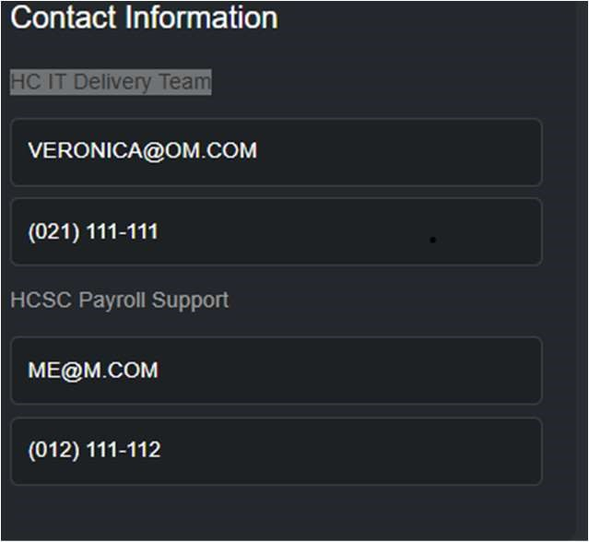

UNDER THE CONTACT INFORMATION MAKE THE BELOW AN INPUT CELL (WHERE IT

SAYS, “HC IT DELIVERY TEAM” AS THIS COULD BE ANY TEAM. KEEP THE FORMAT AS IS

BUT LEAVE SPACE TO COMPLETE THE 3 MOST IMPORTANT PERSONS INVOLVED IN THE

SOP, IE, SPACE TO COMPLETE THE PERSON’S NAME & SURNAME, CONTACT DETAILS AND THE PERSONS ROLE, THIS MUST BE REPEATED MAXIMUM 3 X,

DO THE SAME FOR THE HCSC PAYROLL SUPPORT SECTION (THIS COULD ALSO CHANGE BUT WILL BE LIMITED TO THE FOLLOWING TEAMS (HCSC PAYROLL SUPPORT: PROCESS OWNER WILL BE SHARON KOFF, HCSC SUPPORT CENTRE:

PROCESS OWNER WILL BE NAEEMA CASSIEM, PAYROLL ACCOUNTING AND TAX:

PROCESS OWNER WILL BE DENZIL BARTLETT, SHARE SCHEME: PROCESS OWNER

WILL BE ROBERT MURPHY, HRMIS: PROCESS OWNER WILL BE FAIEK CAROLISEN (CREATE DROPDOWN MENU FOR THIS AND THEN CONTACT DETAILS CAN BE MANUALLY INPUTTED.

LEAVE SPACE TO INPUT THE ACTUAL DOER/S OF THE PROCESS (FIELDS FOR,

PERSON’S NAME & SURNAME, CONTACT DETAILS AND THE PERSONS ROLE TO BE COMPLETED, THIS MUST BE REPEATED MAXIMUM 3 X,

THEN DO THE SAME AS ABOVE FOR ROYSTON CLARKE (WILL FINAL APPROVAL) HCSC SHARED SERVICES AREA HEAD